Mills Observatory
The Sky in September 2025
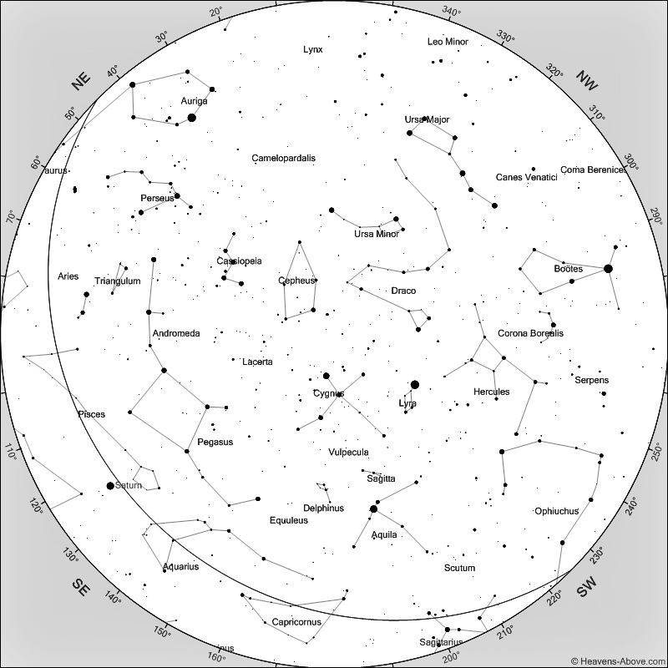
Sky at 9 pm on 15th September 2025
[Chart courtesy of www.heavens-above.com]

Cygnus, the Swan, holds its position due south at a high elevation in September. It is easily recognisable as the Northern Cross with the brightest star Deneb highest in the sky marking the tail of the swan. Deneb is a blue supergiant star at a distance of around 2,000 light years and with a remarkable luminosity of something in the order of 100,000 times that of our Sun. Deneb is around 11 million years old, which is very young compared with the 4.5 billion years of our Sun, and because of its large mass it is developing into a red giant star which will collapse and become a supernova in a few million years.

Cygnus sits in a very rich area of the Milky Way so the various star clusters within the constellation are difficult to locate against the multitude of stars in the Milky Way. There are a number of fainter nebulae within Cygnus which can just be made out with a low powered telescope, but show up well in photographs. Two of my favourites are the North America Nebula and the Veil Nebula. The North America Nebula is a molecular cloud which gets its name from its shape as seen on photographs and is situated close to Deneb. It is an area of new star formation at a distance of 2,500 light years. The Veil nebula is quite different, being the remnant of a supernova which exploded around 15,000 years ago. The remaining strands of debris from the exploded star are remarkably colourful when seen on long exposure photographs.

The constellations of autumn and winter are now rising and rotating from the east, with the Square of Pegasus becoming more prominent in the south-east followed by Andromeda, Perseus and, away to the north-west, Auriga, with the bright star Capella which served so well over the summer months in the north as a marker for displays of noctilucent clouds.

The Sun remains fairly active although solar maximum probably occurred in 2024, but it is still active enough to produce solar flares. Because of the apparent tilt of the Sun’s axis at the equinoxes there is more chance of seeing aurorae during March and September, so have a look northwards during the month just in case! Sunspots can safely.be seen using a proper solar filter or by projecting the Sun’s image through a small telescope onto a sheet of paper. Do not use any form of improvised filter.

The autumnal equinox occurs this year on September 22nd at 7.19 BST. We have seen the elevation of the Sun dropping since the summer solstice in June, and at the time of the autumnal equinox, the Sun is directly over the equator and heading into the southern hemisphere. Days shorten significantly around this time, which means darker, earlier nights, although clocks to not revert to GMT until October 26th.

Mercury rises shortly before the Sun in the first week or so of September, but will be difficult to spot in the brightening dawn sky.

Venus will remain bright in the early eastern morning sky before sunrise, but its elevation will gradually decrease during the month.

Mars sets only a short time after the Sun during September and will not be visible.

Jupiter lies in Gemini and rises at about 12.30am in the north-east. By 6am it will have reached an elevation of 45 degrees in the south-east but will fade into the brightening sky.

Saturn will reach its greatest elevation of about 30 degrees in the south at 1.30am. The rings of Saturn remain at a fine angle to Earth after disappearing from view in March this year, so will not be as spectacular as usually shown in photographs. The angle of the rings will increase gradually until they are at their best in 2032.

The Moon is full on the 7th, at last quarter on the 14th, new on the 21st and at first quarter on the 29th September.

Ken Kennedy
Dundee Astronomical Society

