Mills Observatory
The Sky in October 2025
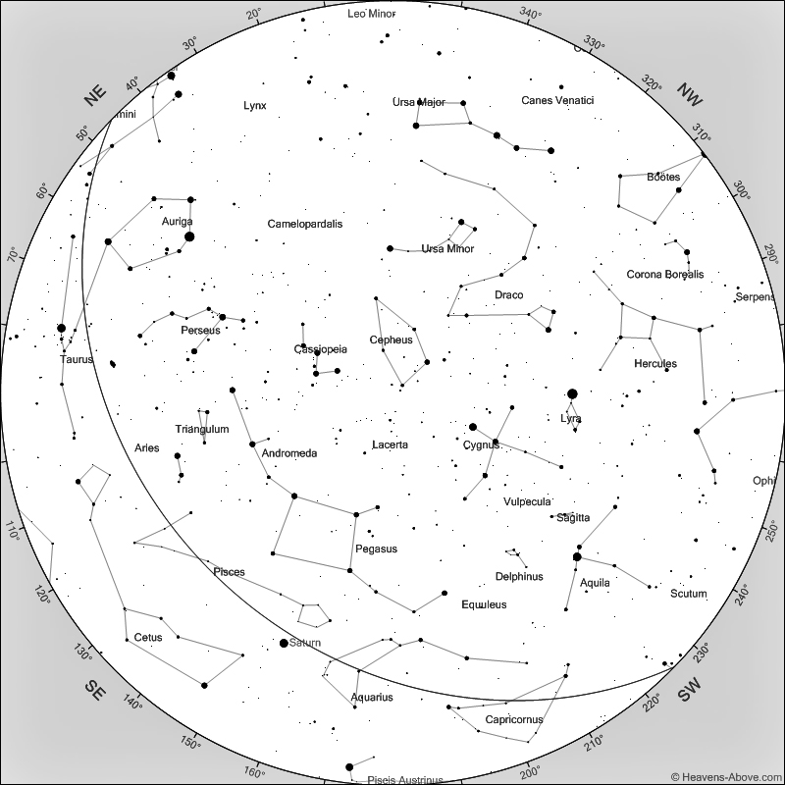

Sky at 9 pm on 15th October 2025
[Chart courtesy of www.heavens-above.com]

As darkness falls in October Cygnus has vacated prime position due south in the sky and the flying horse, Pegasus, is sliding into the Swan’s place. Look high in the southern sky and the Square of Pegasus will be obvious, marking the body of the horse. The four stars are not particularly bright, but are of similar brightness and form a not-quite-perfect square. The winged horse was one of the 48 constellations listed by the 2nd century astronomer Ptolemy. Pegasus is the seventh largest constellation in the sky but contains no particularly bright stars. Remember to think of Pegasus as flying inverted and the front legs, marked by faint stars, extend from the upper right hand star of the Square. The rear leg (there seems to be only one) extends into Andromeda from the upper left star of the Square. The neck and head arise from the lower right star and the nose ends with a slightly brighter star, Enif. If you have a small telescope, scan the sky about three degrees west of Enif and you may see a faint but rather diffuse looking star. With a larger telescope this resolves into a tight ball of stars and is one of the best globular clusters in the northern sky. This is Messier 15, the 15th object of Charles Messier’s 1781 catalogue. A dense group of about 100.000 stars, this cluster lies at a distance of 35,700 light years. The origins of globular clusters are still debated, but some may be the cores of small galaxies whose outer stars have been stripped by our larger Milky Way Galaxy

The Orionid meteor shower will reach its maximum on the night of the 21st/22nd October and will be best seen from midnight until dawn. As the Moon is new on that night, its light will not dim the meteors as they streak across the sky. The Orionid shower is very reliable and more than 20 meteors an hour can be expected at maximum. These meteors are very fast and often leave a glowing train behind which can last for a number of seconds. It’s interesting to think that these streak of light are caused by tiny particles shed by Halley’s Comet and which hit the upper atmosphere at 66 km. per second to rapidly burn up.The Orionid meteor shower is fairly active for a few days before and after the night of maximum. The meteors seem to radiate from Orion which rises at about 11pm, so it’s best to look at an area of sky in a direction other than east.

A few days after the Orionid meteor shower, on Sunday 26th October, British Summer Time ends at 2am when clocks should be turned back by one hour. I, and most astronomers, are happy to see the end of Summer Time as all observations made and predicted are given in Greenwich Mean Time (Universal Time), so after October 26th there will be no dubiety about times of observations.

The first Dundee Astronomical Society meetings of the season will take place at Mills Observatory on the 10th and 24th October at 7.30pm.

Mercury is not visible during October as it is too close to the Sun and sets only shortly after the Sun.

Venus will appear before sunrise in the east at the beginning of the Month but will gradually lose elevation as it moves closer to the Sun. By the end of October it will be very low in the east-south-east as the sky brightens.

Throughout October, Mars sets so shortly after the Sun that it will not be visible.

Jupiter rises at about 11pm and will be highest in the south at 7am as the sky brightens before sunrise.

Saturn rises at about 6pm and will be best placed due south at 11.30pm at an elevation of 30 degrees. Saturn’s rings are still at a narrow angle but will be visible in a small telescope.

The Moon is full on the 7th, at last quarter on the13th, new on the 21st and at first quarter on the 29th October.

Ken Kennedy
Dundee Astronomical Society

