Course Start Date: | Monday 9th October 2017
Course Duration: | 6 Days
Venue: | St Paul’s RC High School
Cost: | £215.00/£250.00
Course Information:
COURSE: New National Pool Lifeguard Qualification + AED Course
COURSE VENUE: St Paul’s Swim & Sport Centre, Gillburn Road, Dundee, DD3 OEH
COURSE DATES: 9th, 10th, 11th, 12th, 13th, 14th October 2017.
COURSE TIMES: 9am – 6pm (This may change slightly due to pool availability
COURSE COST: Under 18 years of age £215.00 / 18 years or over £250.00
FOR FURTHER INFORMATION: Please contact Craig Hutchison on 01382 432405
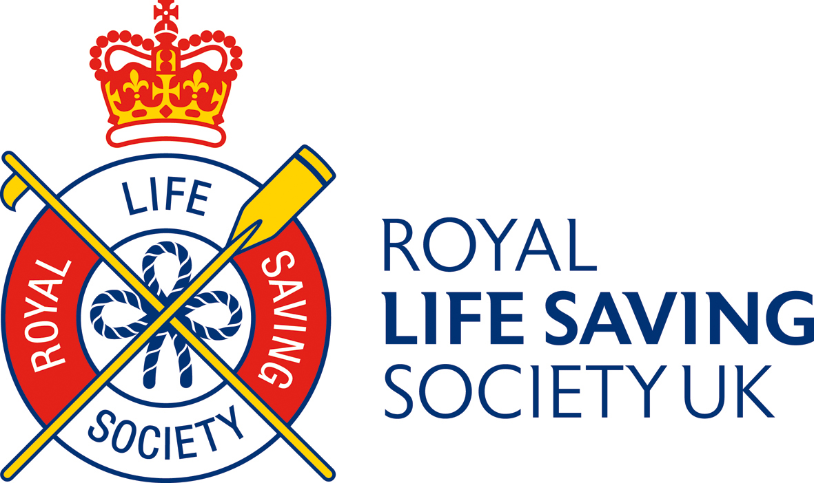
Or e-mail craig.hutchison@leisureandculturedundee.com


