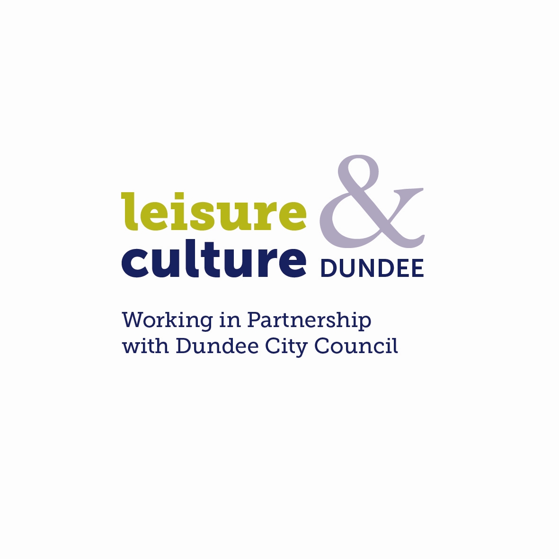

Dundee Musicians Award - Mentoring Project
Supported by Dundee Place Partnership

Mentoring Scheme Application Guidelines

Leisure & Culture Dundee supported by Dundee Place Partnership is offering the opportunity for Dundee based musicians to apply to the Mentoring scheme.

The programme will support two successful applicants to develop and progress their creative practice over 12 months. Tailored to the individual musician, the programme will include mentoring which may lead to the development of skills/training or creation of new work.

A bursary of £500 will be awarded to the successful applicants, plus fees for the mentor and there is a further small budget available for additional support if required.

Criteria

Successful applicants will have demonstrated a level of commitment to their practice
Applicants will be assessed against the following criteria:

- the expected outcome/impact of the financial support on the applicant's creative and professional development
- the quality of the applicant's work to date
- the clarity of purpose behind the submission and reasons given for applying for support
- the relationship of the proposal to current work
- the quality of the supporting material supplied in support of the application (CV, statement of practice, audio material)

Who can apply?

- Musicians living or based within the Dundee City Council boundary
- The project aims to support musicians working in any genre and at any stage of their career.
- It is important that where possible the mentee has a progression route to follow. This should be established from the outset as one of the outcomes or goals for funding i.e. being accepted on a music course, vocal or instrument instruction.

Exclusions

- Applicants will not be considered for projects already started or planned to start before the panel meeting date
- Successful applicants must complete their project and submit a final report before applying to the scheme again

How to apply

Applications should be submitted using the enclosed Application Form, which may be typed or hand-written. If hand-written, it should be completed legibly in black ink. Completed application forms must be signed by the applicant. If completing the form on your own word processing system please ensure that the format remains the same.

Supporting material must be submitted with the application. No more than six images of recent work should be supplied and itemised on the Artwork Submission Form. We request that you select images based on their relevance to your written application.

Music should be provided on a CD or DVD, USB flash drive etc. and saved as JPEG files.
DVDs should last no longer than 2 minutes, but may include edited pieces covering a variety of work.

Please ensure that supporting material is clearly labelled with your name, title of work and date of work.

Please note that Leisure & Culture Dundee can accept no responsibility for damage to or loss of material submitted in support of applications, although we will exercise all possible care in handling this material. Material from successful candidates may be copied and held for use in reports and publicity material.

Decisions

Your application will be considered by members of the DMA Panel. Membership of the panel is made up of invited musicians and industry professionals and a representative from Dundee Place Partnership. The scheme is administered and panel meetings chaired by the Music & Events Development Officer, Leisure & Culture Dundee.

Applicants will be notified within 6 weeks of the deadline on the outcome of their application. You will be contacted by Leisure & Culture Dundee if there is any change to this timetable. Please note: Applicants should leave at least six weeks from the application deadline to the project start before commencing the project.

Applications and supporting material should be sent to:

Halls & Music Development Section
Leisure and Culture Dundee
Caird Hall
City Square
Dundee
DD1 3BB

Closing date for applications: 5pm on Monday 31 July 2017

We are unable to accept late applications.

If you have any queries regarding the application procedures, e-mail: dma@leisureandculturedundee.com

