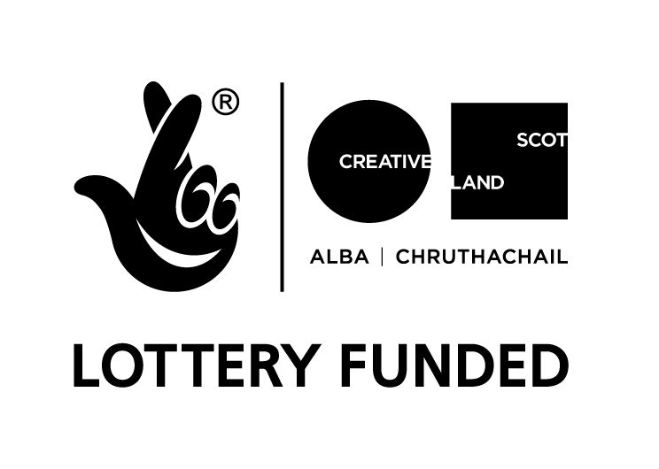


Visual Artist and Craft Maker Awards: Dundee
in partnership with Creative Scotland
#VACMAScotland #VACMADundee
Mentoring Scheme

APPLICATION FORM
Please ensure that you have read the Guidelines carefully before completing this form.

Name:

Address:

Postcode:

Contact Tel No(s):

e-mail:

Artform
Visual Art
Craft

Is there an international focus?
Yes
No
We are asking for the following information to better understand and evaluate our schemes and where support is going and any gaps in its distribution. The information will not be used as part of the assessment process.

What is the principle focus of your application?
Research
Skills Development
Development of New Work
Presentation
Residency
Promotion
Equipment

Number of years developing your practice outside of education
Less than 5 years
5 – 10 years
10 – 20 years
20 + years

Please also complete the VACMA Equalities Monitoring Form, which can be downloaded from the website

1. Tell us about your practice in no more than 50 words

2. Describe the stage you are at in your career (maximum 150 words)

3. How would this programme help to develop your career over the next year?

4. What kind of mentoring support do you feel you need to meet your goals?

5. Are there any specific skills, knowledge, experience or practical training that you would like to progress to help you in your career development e.g. new skills/techniques, website/social media, presenting, marketing?

Please enclose your professional CV

I confirm that all of the information provided in this application is true and accurate

Signature: ________________________________________________________________

Date: ____________________________________________________________________

Artwork Submission Form

Please submit visual material of work undertaken within the last 12 months

Name:

Image format:
(jpeg on CD, DVD, USB, etc)

Please enter details of the artwork submitted in support of your application. We cannot accept original artwork. Please read ‘How to Apply’ notes on guidance form.

We request that all supporting material is clearly labelled with your name and the title of works.

 | Image / Work title | Date | Size | Medium & Description
1
2
3
4
5
6

Please note that Creative Scotland and Leisure & Culture Dundee can accept no responsibility for damage to or loss of material submitted in support of applications, although we will exercise all possible care in handling this material.

