Mills Observatory
The Sky in May 2025
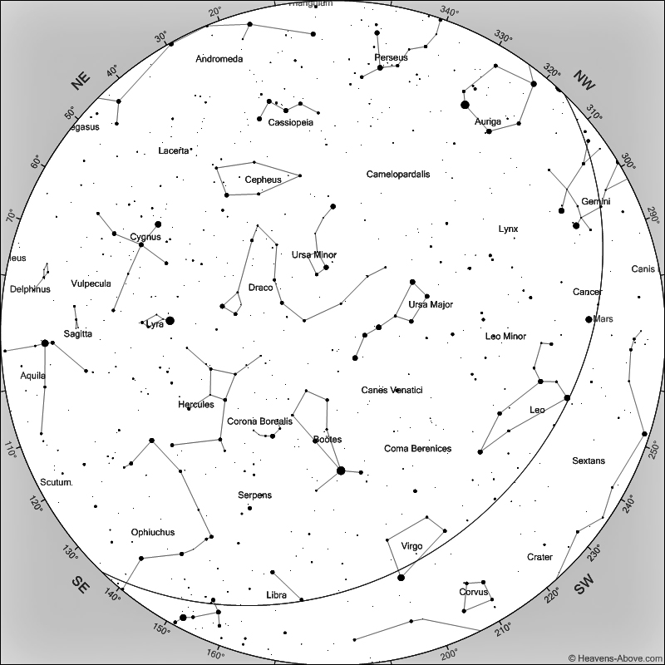
Sky at 11 pm on 15th May 2025
[Chart courtesy of www.heavens-above.com]

As the sky darkens in May evenings, the bright star due south is Arcturus, which I mentioned last month. The fourth brightest star in the night sky, Arcturus is an orange giant star. It is orange in colour because it is 7 billion years old and has used up much of its hydrogen which has caused it to have a cooler surface temperature. It is only 37 light years from the Sun and has about the same mass although it has expanded to 25 times the size of our Sun. This gives us an idea as to how our own Sun will look and behave in about 3-4 billion years when human life on Earth will no longer be possible.

Arcturus is the brightest star of the constellation Böotes, a relatively faint constellation otherwise and which is next to another quite faint constellation, Hercules, towards the east. Hercules has no particularly bright star but is home to the superb globular star cluster, Messier 13. Even a small telescope will allow you to see this compact ball of several hundred thousand stars. The cluster is 22,000 light years distant and is estimated to be around 11.5 billion years old, more than twice the age of our Sun. For any inhabitants of a planet around one of the cluster’s stars, the night sky must be an amazing sight with many close stars never allowing complete darkness.

Further east, Vega, the brightest star of Lyra catches the eye and is the fifth brightest star in the night sky. Another two bright stars, Deneb and Altair, east of Vega, form what is known as the Summer Triangle and will be due south in late August evenings. Patrick Moore popularised the Summer Triangle during the 1950s and said on one occasion during a Sky at Night television programme ‘I casually christened it, never imagining that the name would become widely accepted!’. We will return during the summer months to the three constellations, Lyra, Cygnus and Aquila, which are home to these three bright stars.

Noctilucent clouds (NLC) are very high altitude ice clouds which form in the Earth’s upper atmospheric layer, the mesosphere, at around 85 km. I have studied these clouds for 20 years and they seem to be associated with global climatic change. During these 20 years, first sightings of NLC have been recorded between the last week in May and the first week in June and may appear about an hour after sunset. They may be seen throughout the night in a northerly direction and fade as the morning sky brightens before sunrise. The clouds are a pearly white or slightly blue colour and can be seen as bands or waves, often looking like the pattern of sand left on the shore when the tide goes out. The displays tend to be weaker near solar maximum and more frequent at solar minimum, so it will be interesting to see what appears this year so close to solar maximum. They can usually be seen until the beginning of August.

Mercury rises at about the same time as the Sun during May and will not be visible.

Venus rises about an hour before the Sun and should be bright enough to be seen almost due east before sunrise, but at a very low elevation.

Mars moves westwards through Cancer, entering Leo on the 25th May. The planet is about as bright as a bright star, but its angular diameter has decreased although it retains its distinctive orange colour. Look towards the west at around 11pm.

Jupiter sets in the north-west at about 11.30pm, so there is little time left to observe this planet.

Saturn rises just to the right of Venus and at much the same time before sunrise, but being less bright than Venus will be difficult to locate.

The Moon will be at first quarter on the 4th, full on the 12th, at last quarter on the 20th and new on the 27th May.

Ken Kennedy
Dundee Astronomical Society

