Mills Observatory
The Sky in July 2025
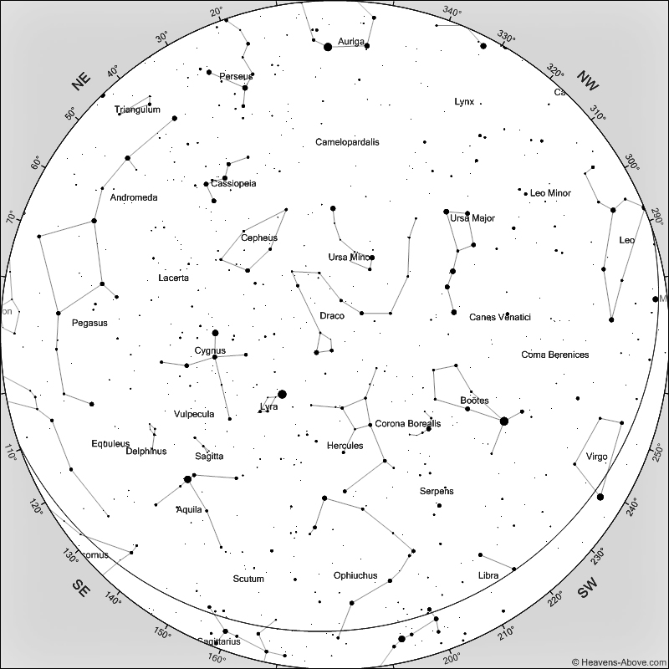
Sky at 10 pm on 15th July 2025
[Chart courtesy of www.heavens-above.com]

By the middle of July we are seeing darker nights slowly returning. Sunrise is at 4.45 am and sunset at 9.50 pm, but for a brief 20 minutes around 1am on the 15th we will have rather deeper darkness, and this will increase until the end of the month when it is dark from 11.30 pm until 3 am. During these darker intervals we can more clearly see the fainter Hercules constellation, and Corona Borealis just to its west. The bright star Vega marks the small constellation Lyra, almost due south, which is home to two favourite objects, Messier 57, the Ring Nebula, and the ‘Double Double’ star Epsilon Lyrae.

When I take photographs of the planets or faint objects in the night sky I like to do this when they are at their highest elevation. This minimises the turbulence caused by the atmosphere and hopefully permits better results. The Ring Nebula in Lyra is highest in the dark night sky during July and August, and this is the best time to have a look at it. It is only a short distance from Vega and quite easily found with a small or moderate sized telescope. The nebula is a small but easily seen, slightly oval ring, and is the expanding remnants of a star which exploded at the end of its life around 7,000 years ago. The star which exploded was probably about the same size as our Sun and at a distance of 2,500 light years.

The star Epsilon Lyrae is also close to Vega and two of the component pairs of this multiple star can easily be separated using binoculars. However, a telescope is required to separate the two stars in each of the doubles as they are only less than 3 arc-seconds apart. These four stars orbit each other with the more distant pairs taking hundreds of thousands of years to complete an orbit, but the closer pairs taking in the order of 1,200 years for their orbits. This star group is at a distance of 600 light years and appear white in colour as they are hotter than our own yellow Sun.

Following Lyra, to the east, is the constellation Cygnus, the Swan, now gaining elevation as it ‘flies’ down the Milky Way. Its brightest star is Deneb, whose name is derived from the Arabic word for tail. At the other end of Cygnus is the superb double star Albirio. The origin of the name is uncertain but may have come from Ptolemy’s Almagest as ‘ab ireo’ and was later applied to the star at the head of the bird. Being so high in the sky, Cygnus will be a constant companion into autumn months.

During the first week of July, Mercury sets rather less than an hour after the Sun. Because of the extended summer twilight it will make an almost impossible visual target and it unlikely to be seen throughout the month.

Venus rises about two hours before the Sun and will be bright towards the east-north-east at an elevation of 15 degrees. If you are an early riser, look for it between 4 and 5 am.

Mars can be found in the west after sunset. It sets about two hours after the Sun and will be in twilight at an elevation of about 5 degrees so will be as difficult to locate as Mercury this month.

Jupiter will reappear as a morning planet rising in the north-east before the Sun from about the middle of the month and brightening towards the end of July when it will reach about 10 degrees elevation.

Saturn rises in the east at around midnight and will reach an elevation of 25 degrees by 3 am. The rings are still very narrow, but the planet will be better seen later in the year.

The Moon will be at first quarter on the 2nd, full on the 10th, at last quarter on the 18th and new on the 24th July.

Ken Kennedy
Dundee Astronomical Society

