 | 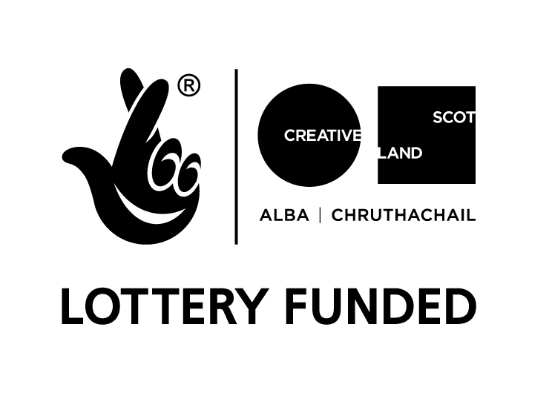

Visual Artist and Craft Maker Awards: Dundee
in partnership with Creative Scotland
#VACMAScotland #VACMADundee

Application Guidelines

In order to support Dundee's creative practitioners to thrive in the city, Leisure & Culture Dundee with Creative Scotland are offering funding to support artists.

Purpose of Fund

The Visual Artist and Craft Maker Awards: Dundee (VACMA) offer grants to Dundee-based artists / craft practitioners towards the costs of developing new work. The purpose of the scheme is to encourage innovative professional practice - through research and professional development activity.

VACMA supports Visual Artists working within a contemporary art practice, which may include drawing, painting, sculpture, print making, photography, moving image and filmmaking.

VACMA also supports Craft Practitioners: contemporary creative work conceived, designed and made by individual practitioners in a wide range of media including ceramics, glass, textiles and jewellery.

Funds available

Grants up to a maximum of £1500 are available. Artists are encouraged to request a sum appropriate to their project and not expect to receive the maximum grant available.

Closing date for applications: Autumn deadline - Wednesday 4 October 2017
Winter deadline - Wednesday 7 February 2018
Who can apply?

- The scheme is open to Dundee based visual artists / craft practitioners, living within the Dundee City Council boundary
- Artists who work in and maintain a studio space in Dundee
- The scheme has a focus on supporting emerging practice but applicants may be of any age and at any stage of their career
- Applicants must not still be in education

Criteria

Successful applicants will have demonstrated a level of commitment to their practice and will already have achieved a body of work outwith formal education.

Applicants will be assessed against the following criteria:
- the quality of the applicant's work
- the expected impact of the financial support on the applicant's creative development
- the clarity of purpose behind the submission and reasons given for applying for an award
- the quality of the supporting material supplied in support of the application (CV, statement of practice, visual material)

Exclusions

- Applicants will not be considered for projects already started or planned to start before the panel meeting date
- Funding will not be awarded to students in education
- Artists cannot apply to the Visual Artist and Craft Maker Awards: Dundee and other VACMA schemes or Creative Scotland for support for the same project
- Applications to run community and/or educational projects are not eligible
- Applications for business development will not be considered
- Applications for film-making projects that fall outwith the visual arts context are not eligible
- Successful applicants must complete their project and submit a final report before applying to the scheme again

How to apply

Applications should be submitted using the enclosed Application Form, which may be typed or hand-written. If hand-written, it should be completed legibly in black ink. Completed application forms must be signed by the applicant. If completing the form on your own word processing system please ensure that the format remains the same.

Supporting visual material must be submitted with the application. No more than six images of recent work should be supplied and itemised on the Artwork Submission Form. We request that you select images based on their relevance to your written application. These must all be of post-Art College work.

Images should be provided on a CD or DVD, USB flash drive etc and saved as JPEG files.
DVDs should last no longer than 2 minutes, but may include edited pieces covering a variety of work.

Please ensure that supporting material is clearly labelled with your name, title of work and date of work. Original artwork will not be accepted as support to any application.

All Visual material will be returned. Please note that Creative Scotland and Leisure & Culture Dundee can accept no responsibility for damage to or loss of material submitted in support of applications, although we will exercise all possible care in handling this material. Visual material from successful candidates may be copied and held for use in reports and publicity material.

Further supporting guidance is available from Creative Scotland at the link below.

www.creativescotland.com/vacma

Quotes

For high value funding requests where elements of the project are provided by a third party e.g. air travel or equipment, 2 reliable quotes must be submitted with your application. If quotes are not provided your application may not be considered.

Decisions

Your application will be considered by members of the VACMA Panel. Membership of the panel is made up of invited artists and curators. The scheme is administered and panel meetings chaired by a member of Leisure & Culture Dundee.

Applicants will be notified within 8 weeks of the deadline on the outcome of their application. You will be contacted by Leisure & Culture Dundee if there is any change to this timetable.

Applications, supporting material and VACMA Equalities Monitoring Form should be sent to:

The VACMA:Dundee Administrator
The McManus: Dundee's Art Gallery & Museum
Albert Square, Dundee, DD1 1DA

Or send by email to
themcmanus@leisureandculturedundee.com

Closing date for applications: Autumn deadline - Wednesday 4 October 2017
Winter deadline - Wednesday 7 February 2018

